Tab 1

Lost & Found Database
Team 4
Carter Adrias, Timothy Baldwin, Alexander Eischeid, Kundana Golla, Jiaer (Grace) Ji, Tina Wondimu
INLS 523 – 001
28 April 2025

Table of Contents
Table of Contents 2
Problem Description 3
Requirements gathering 3
Epic and User Stories 3
Entity Relationship Model Diagram 4
Discussion 5
Relationship Sentences 5
Additional Information 5
Normalized Relations and Functional Dependencies 5
Location Relation 5
Item Relation 6
Type Relation 8
Color Relation 9
Duration Relation 9
Contact_info Relation 10
Relational Model 11
Discussion 12
SQL DDL 12
Entities & Primary Keys 12
Foreign Keys & Other Notable Changes: 14
Adding Data to the Tables using SQL INSERT Statements 15
Discussion 17
Application Implementation 19
Common Items Types Per Location Report 19
Average Claim Time by Item Type Report: 19
Conclusion 21

Problem Description
The primary objective of this database is to address the issue of students frequently losing their belongings on campus. This problem poses challenges in tracking and retrieving these items, leading to difficulties in locating what was lost, identifying the rightful owner, and determining the location of the misplaced items.
A database for the lost-and-found system emerges as the most suitable solution to this problem. It offers an organized and structured manner to store a wealth of information. This is achieved by creating separate tables for various entities, such as locations, dates, items, and contact details. When someone reports a lost item, all relevant information, including the location, type, and any accompanying descriptions, is securely stored.
In contrast, a traditional notebook-based system can lead to errors and inconsistencies in data storage. The database, on the other hand, ensures efficient and accurate record-keeping.
Real-world examples of the importance of structured data management can be observed in various industries. For instance, businesses use structured data to track their products, while libraries maintain comprehensive records of their books. Without a systematic approach to bookkeeping, libraries face significant challenges in locating specific titles and risk losing track of their collection.
In our context, structured data management not only saves time but also reduces confusion and enhances the overall sense of security and well-being among students regarding their belongings and the ease with which they can find them.

Requirements Gathering
The requirements for the lost-and-found system were identified through a review of existing manual processes and informal tracking methods. Additionally, brief interviews were conducted with staff responsible for handling lost items to better understand their workflows and key functional needs.

Epic and User Stories
Campus lost and found management system: The system will efficiently track, organize, and manage lost and found items on campus, enabling students, faculty, and staff to report lost belongings, search for them quickly, and facilitate easy returns.

User stories:
- As a student, I want to quickly inquire about an item I've lost, including descriptions, images, and last-known locations, so I can improve my chances of recovering it promptly.
- As a student or staff member who found an item, I want to easily report details and the location where the item was discovered, so the rightful owner can locate and claim their belongings swiftly.

Entity Relationship Model Diagram
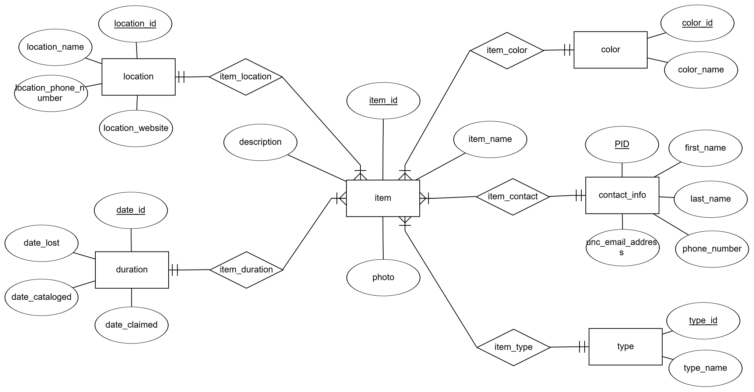
Logical model:
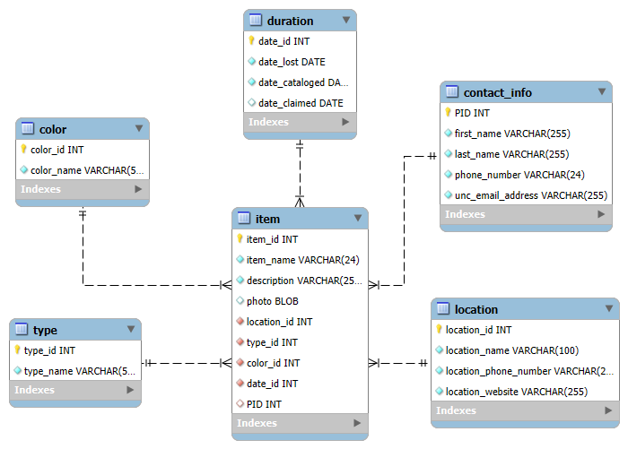

Discussion
What We Like About This Model:
- The model is clear and concise. All relationships are mapped, and the model has appropriate names for each entity, attribute and relationship.
- The model also explicitly defines each entity’s cardinality with another entity.
- All entities’ primary keys have been displayed in the model.
- Foreign keys are well represented across the logical model, ensuring referential integrity between tables.

Relationship Sentences
- One Duration set (date_id, date_lost, date_cataloged and date_claimed) can be linked to one or more Items.
- One Item must be assigned to one Duration.
- One Location can be linked to one or more Items.
- One Item must be found at one location.
- One Color can be associated with one or more Items.
- One Item must be associated with one Color.
- One Contact_Info set (PID, first_name, last_name, phone_number and unc_email_address) can claim one or more Items.
- One Item may be claimed by one Contact_Info.
- One Type can categorize one or more Items.
- One Item must be associated with one Type.

Additional Information
- The date_lost attribute in the duration entity represents the date an item was found in a lost-and-found location (e.g., Student Union, Kenan-Flagler Business School).
- The date_cataloged attribute represents the date an item was entered into the database.
- The date_claimed attribute represents the date an item was claimed by a student.
- The contact_info entity represents the student who claimed an item (i.e., it is the student who owns the missing item).

Normalized Relations and Functional Dependencies

Location Relation
location(location_id (PK), location_name, location_phone, location_website)
Sample Data:
location_id | location_name | location_phone_number | location_website
1 | Student Union | (919) 962-2285 | https://carolinaunion.unc.edu/
2 | Davis Library | (919) 962-1053 | https://library.unc.edu/davis/
3 | Student Recreation Center | (919) 962-4772 | https://campusrec.unc.edu/
4 | Kenan-Flagler Business School | (919) 962-5327 | https://www.kenan-flagler.unc.edu/
5 | Lenoir Dining Hall | (800) 862-6325 | https://dining.unc.edu/

Primary Key: location_id

FD1: location_id → location_name, location_phone_number, location_website

Normal Forms:
- 1NF:
  - All attributes are atomic, and each attribute contains a single value.
  - Meets the definition of 1NF.
- 2NF:
  - Every attribute that is not part of any candidate key must be functionally dependent on the entire primary key.
  - No partial key dependencies, since the primary key consists of a single attribute (location_id).
- 3NF:
  - The relation is in 2NF, and there are no transitive dependencies among nonprime attributes.
  - No transitive dependencies exist.
- BCNF:
  - All determinants are candidate keys.

Item Relation
item(item_id (PK), item_name, description, photo, location_id (FK), type_id (FK), color_id (FK), date_id (FK), PID (FK))
Sample Data:
item_id | item_name | description | photo | location_id | type_id | color_id | date_id | PID
1 | water bottle | Dented bottle with two flower stickers found on the first floor | NULL | 1 | 1 | 1 | 1 | 730283540
2 | earbuds | Has a green lanyard attached to the case and was found on the seventh floor | file:///C:/Users/LostFoundAdministrator/Pictures/airpods.jpeg | 2 | 2 | 2 | 2 | 730287541
3 | notebook | 150-page notebook located next to the front desk | NULL | 3 | 3 | 3 | 3 | 730187542
4 | phone | contains nature charms and stick-on wallet with five cards | file:///C:/Users/LostFoundAdministrator/Pictures/purple_iphone.jpeg | 4 | 4 | 4 | 4 | NULL
5 | keyring | UNC motif with a silver clasp | file:///C:/Users/LostFoundAdministrator/Pictures/unc_keychain.jpeg | 5 | 5 | 5 | 5 | NULL

Primary Key: item_id

FD1: item_id → item_name, description, photo, location_id, type_id, color_id, date_id, PID

Normal Forms:
- 1NF:
  - All attributes contain only atomic values
  - There are no repeating groups or arrays
  - Relation satisfies 1NF
- 2NF
  - Must be in 1NF and have no partial dependencies
  - The primary key is a single attribute (item_id), so no partial dependency is possible
  - Relation satisfies 2NF
- 3NF
  - Must be in 2NF and have no transitive dependencies among non-prime attributes
  - All non-prime attributes depend only on item_id
  - External lookups (foreign keys) are acceptable, because they reference other tables, not other non-key attributes within item
  - Relation satisfies 3NF

- BCNF:
  - All determinants are candidate keys
  - All determinants in the relation are candidate keys
  - Relation satisfies BCNF

Type Relation
type(type_id (PK), type_name)
Sample Data:
type_id | type_name
1 | hydro flask
2 | airpods
3 | stationery
4 | iphone
5 | keychain

Primary key: type_id

FD1: type_id → type_name

Normal Forms:
- 1NF:
  - All attributes contain only atomic values; there are no repeating groups
  - Relation satisfies 1NF
- 2NF:
  - Must be in 1NF, and there are no partial dependencies
  - Satisfies 2NF because type_id is not composite (single attribute primary key)
- 3NF:
  - Must be in 2NF and no transitive dependencies
  - Satisfies 3NF because type_name depends only on type_id
- BCNF:
  - All determinants in the relation are candidate keys
  - Satisfies BCNF

Color Relation
color(color_id (PK), color_name)

Sample Data:
color_id | color_name
1 | silver
2 | white
3 | red
4 | purple
5 | blue

Primary key: color_id

FD1: color_id → color_name

Normal Forms:
- 1NF:
  - All attributes contain only atomic values; no repeating groups
  - Relation satisfies 1NF
2. 2NF:
  - Must be in 1NF, and there are no partial dependencies
  - Satisfies 2NF because color_id is not composite
3. 3NF:
  - Must be in 2NF and no transitive dependencies
  - Satisfies 3NF because color_name depends only on color_id
4. BCNF:
  - All determinants in the relation are candidate keys
  - Satisfies BCNF

Duration Relation
duration(date_id (PK), date_lost, date_cataloged, date_claimed)
Sample Data:
date_id | date_lost | date_cataloged | date_claimed
1 | 2025-01-01 | 2025-01-02 | 2025-01-05
2 | 2025-01-02 | 2025-01-05 | 2025-02-14
3 | 2025-01-05 | 2025-02-14 | 2025-03-08
4 | 2025-02-14 | 2025-03-08 | NULL
5 | 2025-03-08 | 2025-03-22 | NULL

Primary Key: date_id
FD1: date_id → date_lost, date_cataloged, date_claimed
Normal Forms:
- 1NF:
  - All attributes contain only atomic values, there are no repeating groups or arrays
  - Relation satisfies 1NF because all attributes are atomic
- 2NF:
  - Must be in 1NF and no partial dependencies
  - Relation satisfies 2NF because date_id is not composite
- 3NF:
  - Must be in 2NF and no transitive dependencies
  - Relation satisfies 3NF because all non-key attributes depend only on date_id
- BCNF:
  - Relation satisfies BCNF because all FDs have the primary key date_id on the left-hand side, which is a superkey

Contact_info Relation
contact_info(PID (PK), first_name, last_name, phone_number, unc_email_address)
Sample Data:
PID | first_name | last_name | phone_number | unc_email_address
730283540 | Amber | Jackson | (919) 458-2340 | amber@ad.unc.edu
730287541 | Chris | Rockwell | (984) 762-0923 | cr05@ad.unc.edu
730187542 | Jenny | Coleman | (774) 381-6531 | jennyc@ad.unc.edu

Primary Key: PID

FD1: PID -> first_name, last_name, phone_number, unc_email_address

Normal Forms:
- 1NF:
  - All attributes must be atomic, and the value of any attribute in a row must be a single value
  - Meets the definition of the relation
- 2NF
  - Every attribute that is not part of any candidate key must be functionally dependent on the primary key.
  - No partial key dependencies
- 3NF:
  - The relation is in 2NF, and no nonprime attribute is transitively dependent on the primary key.
  - No transitive dependencies
- BCNF:
  - All determinants are candidate keys (PID is a superkey)

Relational Model
Location ( location_id (key), location_name, location_phone_number, location_website )
Type ( type_id (key), type_name )
Color ( color_id (key), color_name )
Duration ( date_id (key), date_lost, date_cataloged, date_claimed )
Contact_Info (PID (key), first_name, last_name, phone_number, unc_email_address )
Item ( item_id (key), item_name, description, photo, location_id (fk), type_id (fk), color_id (fk), date_id (fk), PID (fk) )

Discussion
In developing the relational model for the Lost and Found database, normalization was a critical part of the design process. The first step involved identifying all entities needed to accurately represent the data, such as locations, items, item types, colors, contact information, and dates related to lost and found events. Each entity was analyzed individually to determine its attributes and appropriate primary keys. From there, we examined functional dependencies to ensure that each non-key attribute depended entirely on the primary key, allowing us to achieve Second Normal Form (2NF).
A key challenge during normalization was balancing simplicity with relational integrity. Since the item table required references to several other entities (location, type, color, date, and contact info), it resulted in multiple foreign keys. Managing these references carefully was necessary to maintain 2NF and 3NF without creating overly complex join operations. Another challenge was ensuring that attributes such as dates (in the duration table) and personal contact information were not unnecessarily repeated across other relations, which was solved by separating them into distinct tables and linking them through foreign keys.
Overall, normalization up to Boyce-Codd Normal Form (BCNF) helped eliminate redundancy, maintain consistency, and improve the efficiency of data storage and retrieval. Although splitting data into multiple related tables adds slight complexity to query writing (due to necessary JOIN operations), it ultimately ensures the system remains scalable, easier to update, and less prone to anomalies such as update, insert, or delete errors. By following a methodical normalization process, the final database design strikes an effective balance between structure, integrity, and usability.

SQL DDL

Entities & Primary Keys

The following SQL code creates the six tables from the normalization section in MySQL (i.e., location, type, color, duration, contact_info and item) and adds the Primary Key definitions to each entity:
1. location:
CREATE TABLE location
(
location_id INT AUTO_INCREMENT PRIMARY KEY,
location_name varchar(100) NOT NULL,
location_phone_number varchar(24) NOT NULL,
location_website varchar(255) NOT NULL
);
2. type:
CREATE TABLE type
(
type_id INT AUTO_INCREMENT PRIMARY KEY,
type_name varchar(50) NOT NULL
);
3. color:
CREATE TABLE color
(
color_id INT AUTO_INCREMENT PRIMARY KEY,
color_name varchar(50) NOT NULL
);
4. duration:
CREATE TABLE duration
(
date_id INT AUTO_INCREMENT PRIMARY KEY,
date_lost date NOT NULL,
date_cataloged date NOT NULL,
date_claimed date
);
5. contact_info:
CREATE TABLE contact_info
(
PID INT PRIMARY KEY,
first_name varchar(255) NOT NULL,
last_name varchar(255) NOT NULL,
phone_number varchar(24) NOT NULL,
unc_email_address varchar(255) NOT NULL
);
6. item:
CREATE TABLE item
(
item_id INT AUTO_INCREMENT PRIMARY KEY,
item_name varchar(24) NOT NULL,
description varchar(255) NOT NULL,
photo BLOB,
location_id INT NOT NULL,
type_id INT NOT NULL,
color_id INT NOT NULL,
date_id INT NOT NULL,
PID INT
);

Foreign Keys & Other Notable Changes:

The following SQL code adds FOREIGN KEY definitions to the item table to connect all the entities:
1. location_id foreign key in the item entity:
ALTER TABLE item
ADD CONSTRAINT fk_item_location
FOREIGN KEY (location_id) REFERENCES location(location_id) ON DELETE CASCADE;
2. type_id foreign key in the item entity:
ALTER TABLE item
ADD CONSTRAINT fk_item_type
FOREIGN KEY (type_id) REFERENCES type(type_id) ON DELETE CASCADE;
3. color_id foreign key in the item entity:
ALTER TABLE item
ADD CONSTRAINT fk_item_color
FOREIGN KEY (color_id) REFERENCES color(color_id) ON DELETE CASCADE;
4. date_id foreign key in the item entity:
ALTER TABLE item
ADD CONSTRAINT fk_item_date
FOREIGN KEY (date_id) REFERENCES duration(date_id) ON DELETE CASCADE;
5. pid foreign key in the item entity:
ALTER TABLE item
ADD CONSTRAINT fk_item_pid
FOREIGN KEY (PID) REFERENCES contact_info(PID) ON DELETE CASCADE;

Adding Data to the Tables using SQL INSERT Statements

1. location entity data entry:
INSERT INTO location (location_name, location_phone_number, location_website ) VALUES ('Student Union', '(919) 962-2285', 'https://carolinaunion.unc.edu/');
INSERT INTO location (location_name, location_phone_number, location_website ) VALUES ('Davis Library', '(919) 962-1053', 'https://library.unc.edu/davis/');
INSERT INTO location (location_name, location_phone_number, location_website ) VALUES ('Student Recreation Center', '(919) 962-4772', 'https://campusrec.unc.edu/' );
INSERT INTO location (location_name, location_phone_number, location_website ) VALUES ('Kenan-Flagler Business School', '(919) 962-5327', 'https://www.kenan-flagler.unc.edu/');
INSERT INTO location (location_name, location_phone_number, location_website ) VALUES ('Lenoir Dining Hall', '(800) 862-6325', 'https://dining.unc.edu/');
2. type entity data entry:
INSERT INTO type (type_name) VALUES ('hydro flask');
INSERT INTO type (type_name) VALUES ('airpods');
INSERT INTO type (type_name) VALUES ('stationery');
INSERT INTO type (type_name) VALUES ('iphone');
INSERT INTO type (type_name) VALUES ('keychain');
3. color entity data entry:
INSERT INTO color (color_name) VALUES ('silver');
INSERT INTO color (color_name) VALUES ('white');
INSERT INTO color (color_name) VALUES ('red');
INSERT INTO color (color_name) VALUES ('purple');
INSERT INTO color (color_name) VALUES ('blue');
4. duration entity data entry:
INSERT INTO duration (date_lost, date_cataloged, date_claimed) VALUES ('2025-01-01', '2025-01-02', '2025-01-05');
INSERT INTO duration (date_lost, date_cataloged, date_claimed) VALUES ('2025-01-02', '2025-01-05', '2025-02-14');
INSERT INTO duration (date_lost, date_cataloged, date_claimed) VALUES ('2025-01-05', '2025-02-14', '2025-03-08');
INSERT INTO duration (date_lost, date_cataloged, date_claimed) VALUES ('2025-02-14', '2025-03-08', NULL);
INSERT INTO duration (date_lost, date_cataloged, date_claimed) VALUES ('2025-03-08', '2025-03-22', NULL);
5. contact_info data entry:
INSERT INTO contact_info (PID, first_name, last_name, phone_number, unc_email_address) VALUES (730283540, 'Amber', 'Jackson', '(919) 458-2340', 'amber@unc.edu');
INSERT INTO contact_info (PID, first_name, last_name, phone_number, unc_email_address) VALUES (730287541, 'Chris', 'Rockwell', '(984) 762-0923' , 'cr05@unc.edu');
INSERT INTO contact_info (PID, first_name, last_name, phone_number, unc_email_address) VALUES (730187542, 'Jenny', 'Coleman', '(774) 381-6531', 'jennyc@unc.edu');
6. item entity data entry:
INSERT INTO item (item_name, description, photo, location_id, type_id, color_id, date_id, PID) VALUES ('water bottle', 'dented bottle with two flower stickers found on the first floor', NULL, 1, 1, 1, 1, 730283540);
INSERT INTO item (item_name, description, photo, location_id, type_id, color_id, date_id, PID) VALUES ('earbuds', 'has a green lanyard attached to the case and was found on the seventh floor', 'file:///C:/Users/LostFoundAdministrator/Pictures/airpods.jpeg', 2, 2, 2, 2, 730287541);
INSERT INTO item (item_name, description, photo, location_id, type_id, color_id, date_id, PID) VALUES ('notebook', '150-page notebook located next to the front desk', NULL , 3, 3, 3, 3, 730187542);
INSERT INTO item (item_name, description, photo, location_id, type_id, color_id, date_id, PID) VALUES ('phone', 'contains nature charms and a stick-on wallet with five cards', 'file:///C:/Users/LostFoundAdministrator/Pictures/purple_iphone.jpeg', 4, 4, 4, 4, NULL);
INSERT INTO item (item_name, description, photo, location_id, type_id, color_id, date_id, PID) VALUES ('keyring', 'UNC motif with a silver clasp', 'file:///C:/Users/LostFoundAdministrator/Pictures/unc_keychain.jpeg', 5, 5, 5, 5, NULL);

SQL Join Code
SELECT item.item_name, item.description, item.photo, location.location_name, location.location_phone_number, location.location_website, type.type_name, color.color_name, duration.date_lost, duration.date_cataloged, duration.date_claimed, contact_info.PID, contact_info.first_name, contact_info.last_name, contact_info.phone_number, contact_info.unc_email_address
FROM item
INNER JOIN location ON item.location_id = location.location_id
INNER JOIN type ON item.type_id = type.type_id
INNER JOIN color ON item.color_id = color.color_id
LEFT JOIN contact_info ON item.PID = contact_info.PID
INNER JOIN duration ON item.date_id = duration.date_id;

Discussion

All primary keys have been set to auto-populate (AUTO_INCREMENT), except for the PID primary key in the contact_info entity.
- The location entity features four non-null attributes. All of these attributes are mandatory to locate items quickly. Additionally, all attributes except the primary key (location_id) have a varchar data type because they contain alphanumeric characteristics (location_name, location_phone_number and location_website).
  - Further Explanations:
    - location_name: This attribute has a length of varchar(100) to concisely record each location’s name.
    - location_phone_number: The phone number attribute has a length of varchar(24) because the E.164 standard requires that all telephone numbers have a maximum length of 15 digits (Wilcock & Mabee, 2023). Therefore, we added a buffer of nine digits to encompass all phone numbers.
    - location_website: This attribute has varchar(255) data type length to accommodate all website links while being concise.
- The type and color entities also have two primary keys and two non-null attributes to sort items into different categories and primary colors.
  - Further Explanations:
    - type_name & color_name: These attributes have a data type of varchar(50) because type and color names can contain alphanumeric characteristics. Furthermore, both attributes only allow 50 characters to ensure easy record keeping and database retrieval.
- The duration entity contains three non-null attributes (date_id (PK), date_lost and date_cataloged) and one attribute that accepts both dates and null values (date_claimed). The date_claimed attribute has this feature to accommodate claimed and non-claimed items.
  - Further Explanation:
    - The non-primary-key attributes (date_lost, date_cataloged and date_claimed) have a date data type to record dates.
- The contact_info entity features five non-null attributes: PID, first_name, last_name, phone_number and unc_email_address. These attributes are mandatory to match each item with the designed student owner.
  - Further Explanations:
    - PID: This attribute is an integer to accommodate all students’ PIDs.
    - First_name, last_name and unc_email_address: These attributes have a data type of varchar because names can contain alphanumeric characteristics. Additionally, these attributes have a date type length of 255 characters to reasonably accommodate all name lengths and emails.
    - phone_number: This attribute also has a data type of varchar and a length of 24 characters due to the E.164 standard.
- The item entity contains four attributes (item_id, item_name, photo and description) and five foreign keys (location_id, type_id, color_id, duration_id and PID). All foreign keys except for the PID are non-null values because each item will match a location, type, color, and date set. The PID foreign key accepts null values because some items are not claimed and do not have a student owner.
  - Further Explanations:
    - item_name: This attribute has a data type and length of varchar(24) to record each item concisely. Additionally, the attribute must always have some value in the database to properly define each item.
    - description: This attribute has a data type and length of varchar(255) because it contains alphanumeric characteristics. Furthermore, it is important for the database operator to record high-quality descriptions of each item; therefore, a large number of characters have been assigned to this attribute.
    - photo: This attribute has a BLOB data type because it stores images. It also allows null values because there may be a large volume of missing items, making it difficult to take photos of each item.
    - location_id, type_id, color_id, date_id and PID: These foreign keys are all integers because they uniquely define each item row in their corresponding entity.
- The location, type, color, duration and contact_info entities need to have data inserted first before the item table (the item table references these table’s primary keys as foreign keys).
All entities should have sufficient data for testing and application development (e.g., reports and queries).

Sources:
Wilcock, J. & Mabee, D. (2023, July 20). Telephone number formats. Microsoft Learn. https://learn.microsoft.com/en-us/globalization/locale/telephone-numbers

Application Implementation

Common Items Types Per Location Report

Question: What are the top item categories lost at each campus location, and how many of each have been reported?

This view aggregates records in the item table by joining location and type to count how many items of each type have been reported per location. It shows which categories are most frequently lost at a location.

Based on Query:

CREATE VIEW item_type_counts_by_location AS
SELECT
location.location_name,
type.type_name,
COUNT(*) AS item_count
FROM item
JOIN location ON item.location_id = location.location_id
JOIN type ON item.type_id = type.type_id
GROUP BY location.location_name, type.type_name
ORDER BY location.location_name, item_count DESC;

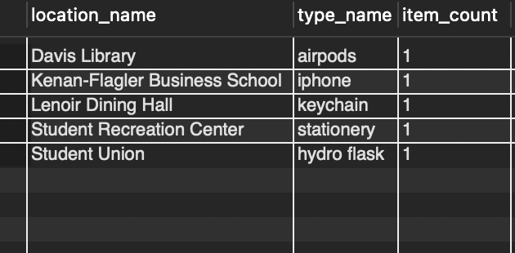

location_name | type_name | item_count
Davis Library | airpods | 1
Kenan-Flagler Business School | iphone | 1
Lenoir Dining Hall | keychain | 1
Student Recreation Center | stationery | 1
Student Union | hydroflask | 1

Average Claim Time by Item Type Report:
Question: On average, how many days pass from when an item is cataloged to when it is claimed, grouped by item type?
By joining items with type and duration, this view shows the average difference in days between date_cataloged and date_claimed for items that have been claimed. It shows the claim turnaround time by item category.
Based on Query:
CREATE VIEW avg_claim_time_by_type AS
SELECT
type.type_name,
ROUND(AVG(DATEDIFF(duration.date_claimed, duration.date_cataloged)))
AS avg_days_to_claim
FROM item
JOIN type ON item.type_id = type.type_id
JOIN duration ON item.date_id = duration.date_id
WHERE duration.date_claimed IS NOT NULL
GROUP BY type.type_name
ORDER BY avg_days_to_claim DESC;
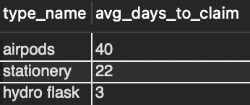
type_name | avg_days_to_claim
airpods | 40
stationery | 22
hydro flask | 3

Conclusion
One challenging aspect of the project was implementing the database in MySQL. We had to brainstorm data types and lengths of each attribute, which required significant research. We also had to determine how to connect and output all the tables through foreign keys and JOIN statements, which became a trial-and-error process. Furthermore, inserting data into each table was tedious. Since we had six entities and around two to nine attributes per entity, there were numerous situations where we would incorrectly spell values or forget characters (e.g., a digit in a PID). Therefore, this required constantly deleting and updating data. This process made our team realize that it was imperative to store copies of SQL code in a Google Document to make changes quickly and have a reference of our work.
One feasible aspect of the MySQL project database implementation was defining all the primary keys. Since we did this process for the candy database implementation assignment, our team had prior knowledge about assigning primary keys and AUTO_INCREMENT constraints. Additionally, another feasible aspect was creating database views/reports. At this project stage, our team had an in-depth understanding of our database and what queries we wanted to produce. We also had a lot of in-class practice creating views, ranging from the SQL joins and views assignment to the windowing homework. Therefore, we were properly equipped to design and execute views in MySQL.
In addition to the technical implementation, we also focused on aligning the database structure with real-world user needs. We created an epic and user stories to envision how students, staff, and administrators would interact with the lost-and-found system. Thinking through these scenarios helped guide our design decisions, ensuring that the database would support efficient logging, searching, and reporting of lost items. By considering both technical functionality and user experience, we strengthened the practicality and usability of our final system.
We also recognized that our database could be easily adapted to a real-world lost-and-found system. By structuring the tables around items, locations, contact information, and timeframes, we created a model that mirrors how physical lost-and-found offices operate. Our design ensures that administrators can efficiently track, update, and retrieve records, while students can quickly search for and claim their lost belongings. This practical structure highlights the database's potential for immediate application beyond an academic setting.
At the same time, we reflected on additional considerations necessary for real-world deployment. While our core model provides a solid foundation for managing lost-and-found items, practical implementation would require further steps, such as cloud-based photo storage, stronger privacy protection for personal information, and a user-friendly web interface to streamline user interactions. Handling missing or incomplete data gracefully would also be critical for smooth daily operations. Thinking through these challenges helped us appreciate the need to balance technical design with usability, scalability, and real-world practicality.
If we were to approach this project differently, we would probably spend more time brainstorming each entity and its attributes. This aspect of the process was slightly rushed since we started after the proposed start date; therefore, we would spend more time brainstorming possible entities and attributes.

